**Module 1**

**Assignment 1**

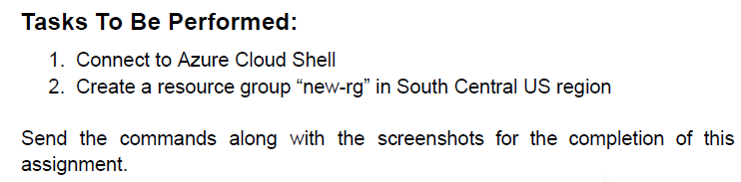

1. Connect to Azure Cloud Shell
2. Create the new-rg by passing the command into Cloud Shell : az group create --name new-rg --location southcentralus

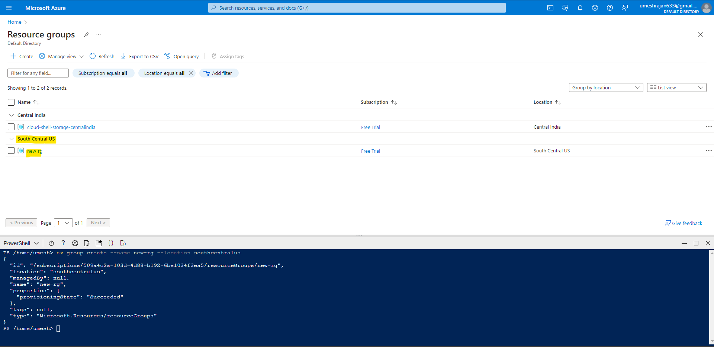

**Assignment 2**

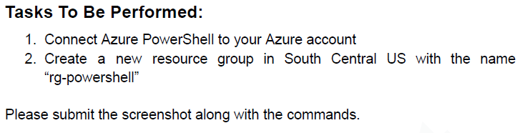

1. Connect to Azure Cloud Shell
2. Create the resource group by passing the command into Cloud Shell : az group create --name rg-powershell --location southcentralus

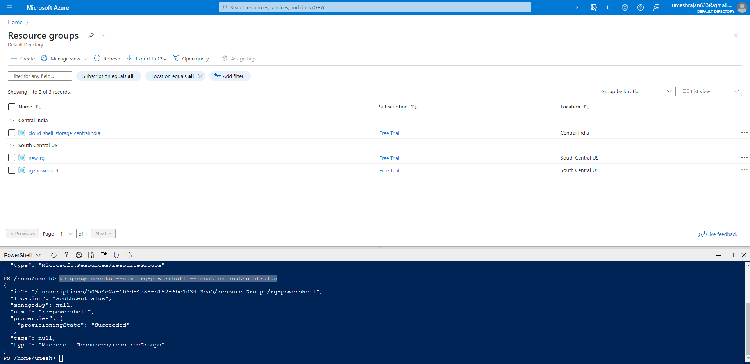

**Assignment 3**

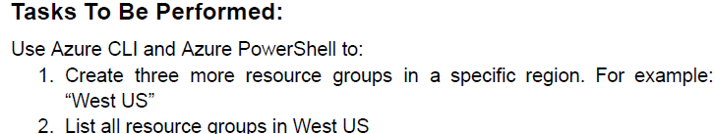

1. Azure CLI :

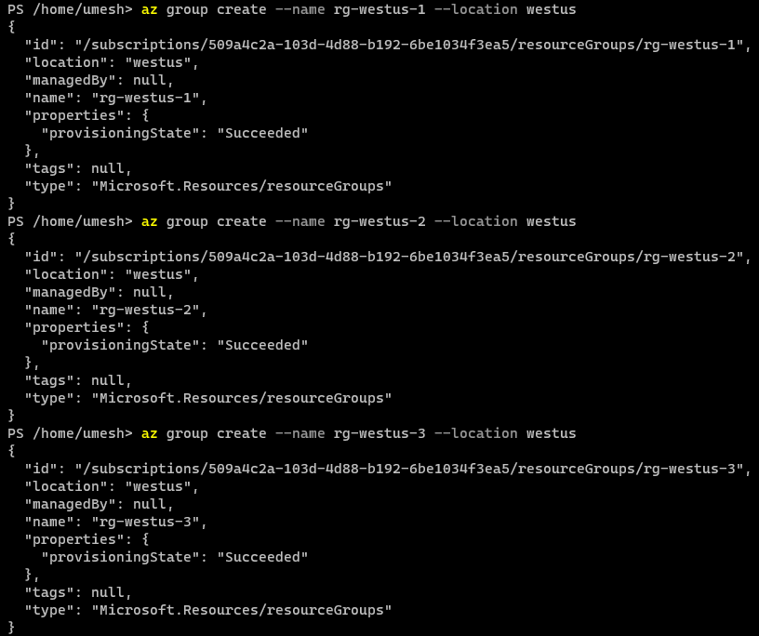

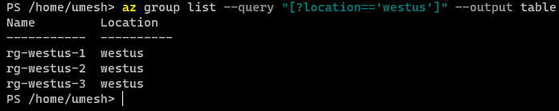

1. Azure Powershell

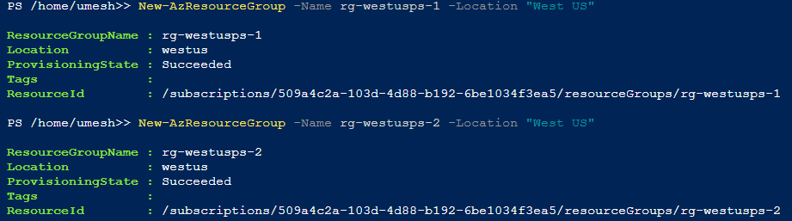

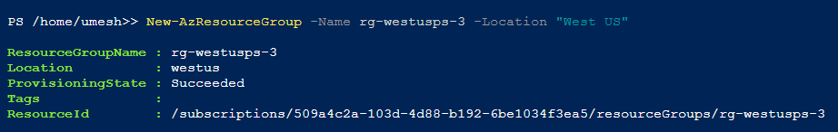

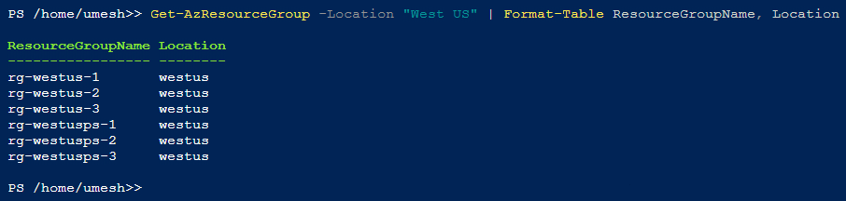

**Assignment 4**

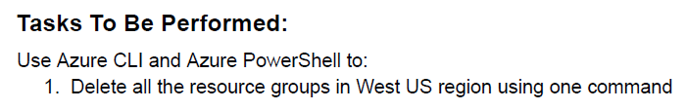

1. Delete all the resources using the command : az group list --query "[?location=='westus'].name" --output tsv | xargs -L1 az group delete --yes --no-wait –name

